The 2022 Summer Experience

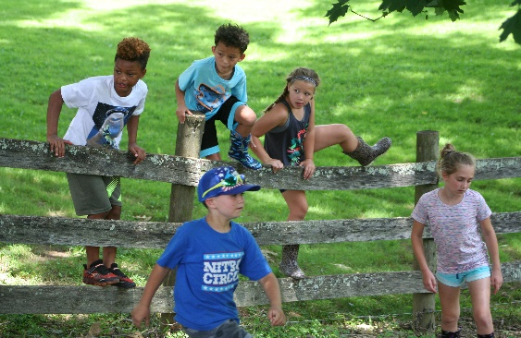
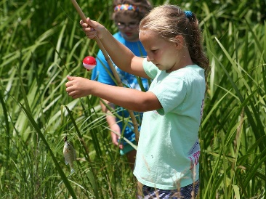
June 20-23 ages 7-12
*planting the seed of self-awareness and self-regulation
9:00-3:00 (drop off 8:30/pick up 3:30)
$340.00
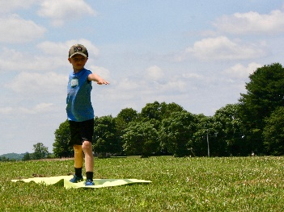
​
June 27-30 ages 7-12
*navigating the growing years through
self-empowerment and growth mindset
9:00-3:00 (drop off 8:30/pick up 3:30)
$340.00
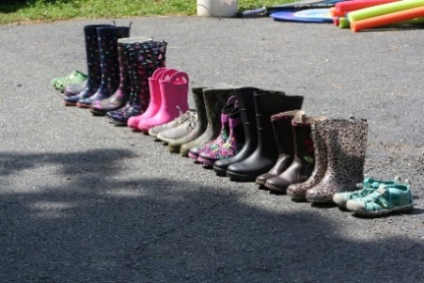
​
July Play Day Wednesdays
13th, 20th, 27th ages 5-12
*unplug and play
9:00-3:00 (drop off 8:30/pick up 3:30)
$85.00
Per day/ Pay as you play
​*
COMPLETE:
Registration form and Liability Waiver
PAY: check, cash or Venmo
Check made payable to:
Farming Me
2239 Price Road
Darlington, MD 21034
Venmo-Raine Archer
Register: Farmingme.com

